
SRM Institute of Science and Technology
Mode of Exam
OFFLINE
College of Engineering and Technology
School of Computing
DEPARTMENT OF COMPUTATIONAL INTELLIGENCE
SRM Nagar, Kattankulathur – 603203, Chengalpattu District, Tamilnadu
Academic Year: 2022-23 (EVEN)
Test: CLAT-2 Date: 04.04.2023
Course Code & Title: 18AIC209T Foundation of Metric Spaces Duration: 1 Hour
Year & Sem: II Year & IV Semester Max. Marks: 25 Marks
Course Articulation Matrix: (to be placed)
Course Learning Outcomes (CO): |  |  |  |  |  | At the end of this course, learners will be able to:
CO-1 : |  | Discover whether examples of metric spaces are complete using Cauchy sequences
CO-3 |  | Understand iterative processes on general spaces
CO-3 |  | Can apply principles and algorithms to evaluate models generated from data
Program Learning Outcomes (PLO)
1 | 2 |  | 3 | 4 | 5 |  | 6 | 7 | 8 | 9 | 10 | 11 | 12 | PSO
Engineering Knowledge | Problem Analysis |  | Design & Development | Analysis, Design, Research | Modern Tool Usage |  | Society & Culture | Environment & Sustainability | Ethics | Individual &Team Work | Communication | Project Mgt. & Finance | Life Long Learning | PSO - 1 | PSO - 2 | PSO – 3
3 | 2 |  | 2 | 3 | - |  | - | 1 | - | - | 3 | 2 | 2 | 2 | 2 | 2
3 | 3 |  | 3 | 2 | 3 |  | - | 2 | 1 | - | 3 | 3 | 2 | 2 | 2 | 2
3 | 3 |  | 2 | 3 | 3 |  | 2 | 2 | 2 | 1 | 3 | 2 | - | 2 | 2 | 2

Part - A (10 x 1 = 10 Marks)
Instructions: Answer all
Q. No | Question | Marks | BL | CO | PO | PI Code
1 | Which one is incorrect for a distance function d?  (a)d(x, y) ≥ 0  (b)d(x, x) = d(y, y)  (c)d(x, y) = d(y, x)  (d)d(x, y) + d(y, z) ≤ d(x, z) | 1 | 1 | 2 | 1,2 | 1.1.1
2 | Topology studies geometric properties of objects that remain unchanged under ______  (a)Continuous deformations  (b)Discontinuous deformations  (c)Abstract deformations  (d) simple formations | 1 | 1 | 2 | 1,2 | 1.1.1
3 | Which one is not a continuous deformation?  (a)Stretching  (b)Bending  (c)Tearing  (d)Twisting | 1 | 1 | 2 | 1 | 2.1.1
4 | Let X be a non-empty set and ℝ be a set of real numbers then d: X × X → ℝ is called  (a)Metric  (b)Distance function  (c)Metric Space  (d) Topology | 1 | 1 | 2 | 1,2 | 2.1.3
5 | For a metric d on a non-empty set X, the metric space is represented as ______  (a)(X, d)  (b)(X, d)→ ℝ  (c)(d, X)  (d)(X:X→ d) | 1 | 1 | 2 | 2 | 2.1.3
6 | From topological point of view, square and circle are ______ (a)Different  (b)Same  (c)Irrelated  (d) collected | 1 | 1 | 3 | 1 | 1.4.1
7 | In topology, we mainly care about the following  (a)Arrangement of shapes  (b)Deformations between shapes  (c)Measurements  (d) No change | 1 | 1 | 3 | 1 | 1.1.1
8 | The elements of τ are called ______  (a)Subsets  (b)Sub-classes  (c)τ -open sets  (d) Sub space | 1 | 1 | 3 | 1 | 2.1.1
9 | The topology of a set containing only ∅ and the set itself is called _______  (a)Discrete topology  (b)Indiscrete topology  (c)Trivial topology  (d) Order Topology | 1 | 1 | 3 | 1 | 1.2.2
10 | If X is a set and τ is a topology on X then (X, τ) is called _______  (a)τ-Topological space  (b)Discrete topological space  (c)Indiscrete topological space  (d)Trivial topology | 1 | 1 | 3 | 1,2 | 1.1.1
Part – B
( 3 x 5 = 15 Marks)
Instructions: Answer any 3
11 | Prove that every open ball in a metric space (X,d) is an open set in (X,d). What about the converse? Justify. | 5 | 4 | 3 | 1,2 | 2.4.1
12 | Show that if (X,d) and are isometric, then they are homeomorphic. | 5 | 3 | 2 | 1,2 | 1.1.2
13 | Explain the following with an example  i.Topological space  ii.Discrete topology  iii.Indiscrete topology | 5 | 2 | 2 | 1,2 | 2.3.2
14 | Explain the properties and representation of Hausdorff space with an example. | 5 | 2 | 3 | 1,2 | 1.1.2

*Performance Indicators are available separately for Computer Science and Engineering in AICTE examination reforms policy.
Course Outcome (CO) and Bloom’s level (BL) Coverage in Questions

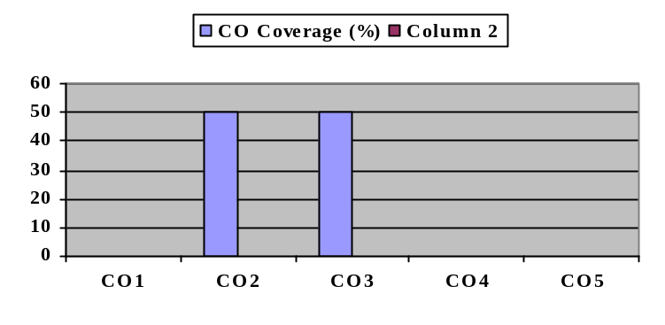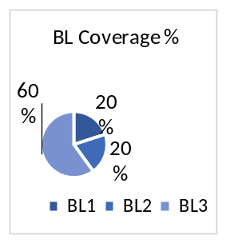

Approved by the Audit Professor/Course Coordinator

